|  |
| --- |
|  |



**12 October 2012** **The Weekly Bulletin of Rotary Club of Kathmandu Mid-Town** **Bc-12.10/012-13**

District : 3292 Web:www.rotarymidtown.org.np Club Id : 26776

**OCTOBER IS VOCATIONAL SERVICE MONTH**

Vocational Service is both the responsibility of a Rotary club and of its members. The role of the club is to implement and encourage the objective by example and by development of projects that help members contribute their vocational talents. The role of members is to conduct themselves, their business­es, and their professions in accordance with Rotary principles and to respond to projects which the club has developed.

Friday, 5 October:

Guest speaker HE Peter W Bodde, US ambassador to Nepal, provided an interesting account of his assignments in several countries – in India, Germany, Pakistan, Malawi and Baghdad after his assignments twice in Nepal in 1982-84 and 1994-97.

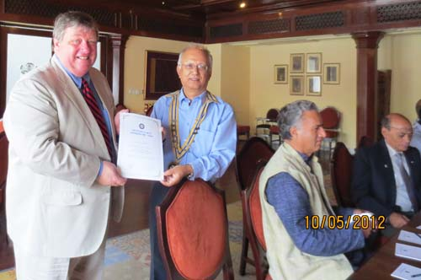

President Devendra providing a token of appreciation to HE Peter Bode for

his visiting and speaking to the Club members.

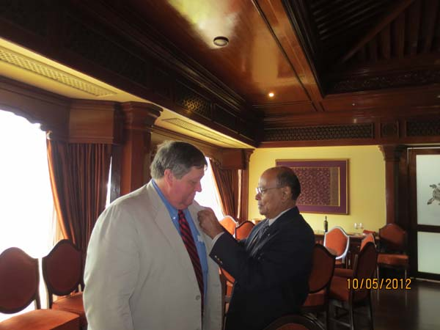

District Governor Rtn Yogendra M Pradhan providing Rotary Pin in advance to

Guest Speaker US Ambassaor Peter W Bodde following His Excellency’s commitment to re-join the Rotary Club of Kathmamndu Mid-Town.

# Weekly Meetings and Programs :

|  |  |  |
| --- | --- | --- |
| Date | Program/Speaker | Program/Topics of Presentation |
| 12 Oct 2012 | Catherine Sue Jenson | My work at Sheer Memorial Hospital |
| ?? | ?? | ?? |
| ?? | ?? | ?? |

Friday, 12 October:

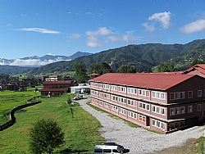

Catherine Sue Jenson, Interim CEO of Scheer Memorial Hospital,

Banepa/Nepal, will be the guest speaker. She will provide

presentation on Scheer Memorial Hospital activities. Catherine

is professionally a nurse, and has served for over 33 years in

her profession.

**Congratulations to Rotaractors of RC Annapurna, Pokhara:**

In the Annapurna Engineering Expo, organized by Rotaract Club of Annapurna/Pokhara, a group of 8 Rotaractors, final year students of Western Regional Engineering Campus/Pokhara, exhibited their scientific inventions.

Rtr. Janak Dhakal and Dipak Kc presented their Innovation of wireless Multimedia Transmission Detecting machine which detect Smoke, Gas and Inform with siren and Light.

Rtr. Amrit Kunwar presented his invention of GPRS System.

Rtr. Satyam and friends presented the Automatic Meter Reading System, which can read the electricity unit from office without visiting home.

Rtr. Narhari Gautam presented his invention of Automatic Alcohol Detection System, which is more advanced than the present machine being used by Nepal Traffic Police.

*Source:* Rtn. Kiran Lal Shrestha, DRCC

Great jobs! Congratulations from the Breakfast Chatter team, Rotary Club of Kathmandu Mid-Town.

**THE TEN COMMANDMENTS OF A GOOD ROTARIAN:**

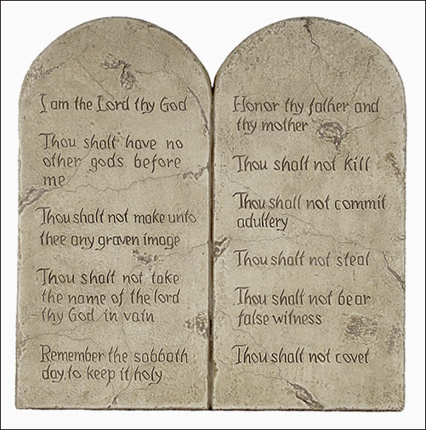

1. Attend Rotary meetings regularly.

2. Keep your financial obligations to Rotary up-to-date.

3. Get better acquainted with your fellow members.

4. Widen your friendships by visiting other Rotary Clubs

and by attending District Conferences and International

Conventions.

5. Help your Clubs' advancement in the realm of

International Understanding, good will and peace.

6. Spread the idea of Service which is the spirit of

Rotary.

7. Practice in your daily living Rotary’s Four Way test

and base your decision on this philosophy which states –

a. Is it the truth?

b. Is it fair to all concerned?

c. Will it build goodwill and better friendships?

d. Will it be beneficial to all concerned?

8. Support Rotary projects with your talent, your time and your finances.

9. Help your Club grow in membership by proposing men and women in the community whom you think would become good Rotarians, and are eligible within the concept of the Classification principle.

10.Never say "no" to a task assigned to you by presiding officers of Rotary.

*Source: Rotarians’ e-Digest, October 2012*

**A drink a day good for middle-aged women, study finds:**

[](http://www.myhealthnewsdaily.com/women-drink-alcohol-daily-healthier-1878/)

For women who like a nice glass of wine at the end of the day, there’s more good news: Even middle-aged women can have about a drink a day of any kind of alcoholic beverage as part of what they do to try to stay healthy as they age, according to new research.

Qi Sun of the Harvard School of Public Health and his colleagues analyzed data collected from 13.984 female nurses participating in the Nurses’ Health Study, an ongoing study examining a variety of health issues.

[](http://www.rttnews.com/Content/HealthNews.aspx?Id=1708615&SM=1)

In a [paper](http://www.plosmedicine.org/article/info%3Adoi%2F10.1371%2Fjournal.pmed.1001090) published online Tuesday by the journal PLoS Medicine, the researchers found that those who consumed 15 grams or less of alcohol a day, which is the equivalent of one drink of any alcoholic beverage, when they were about 58 years old on average were more likely to have good overall health when they were about 70 years old. Those who drank between one-third and 1 drink per day five to seven days a week were almost 50 percent more likely to be in good health when they got older compared with those who did not imbibe.

That was after accounting for other factors, such as smoking. Good overall health was defined as having no major chronic diseases, such as heart disease or diabetes, as well as having no significant decline in their thinking or physical abilities.

“These data suggest that regular, moderate consumption of alcohol at midlife may be related to a modest increase in overall health status among women who survive to older ages,” the researchers wrote.

Now, the researchers stressed that wasn’t the case for women who consumed more than two drinks a day or four drinks or more at a time.

[](http://www.nzherald.co.nz/science/news/article.cfm?c_id=82&objectid=10750376)

The findings fit with current federal dietary guidelines, which recommend up to one drink per day for women and just to two drinks per day for men.

*Source:*Rob Stein/The Washington Post

Understanding the idea of vocational service completely changed my attitude toward my work,

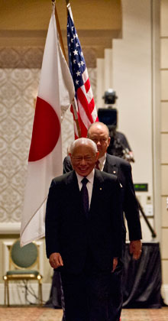

and toward my own purpose in life. I realized that the goal of a person doing business is not only

to earn a living. The purpose is to be a contributing member of the community, to make the

community stronger, and to help make other people’s lives better.

**RI President Sakuji Tanaka**

On Lighter Side :

Click here ⇩



**A THOUGHT FOR THE DAY:**

**It has been said that a pretty face is a passport.**

**But it's not, it's a visa, and it runs out fast.**

*courtesy:* Rtn Dr Isabella C Bassingana Khadka

**Great Quotes:**

WHEN YOU ARE IN THE LIGHT, EVERYTHING FOLLOWS YOU,

BUT WHEN YOU ENTER INTO THE DARK, EVEN YOUR OWN SHADOW DOESN'T FOLLOW YOU.



*courtesy:* Rtn Dr Isabella C Bassingana Khadka

NB: If you have any information/photo that may be of interest to Rotarians send them to

BC Editor: RR Shrestha email: rryesrr@gmail.com

## 12 Oct 2012 The Weekly Bulletin of Rotary Club of Kathmandu Mid-Town bc-12.10/012-13